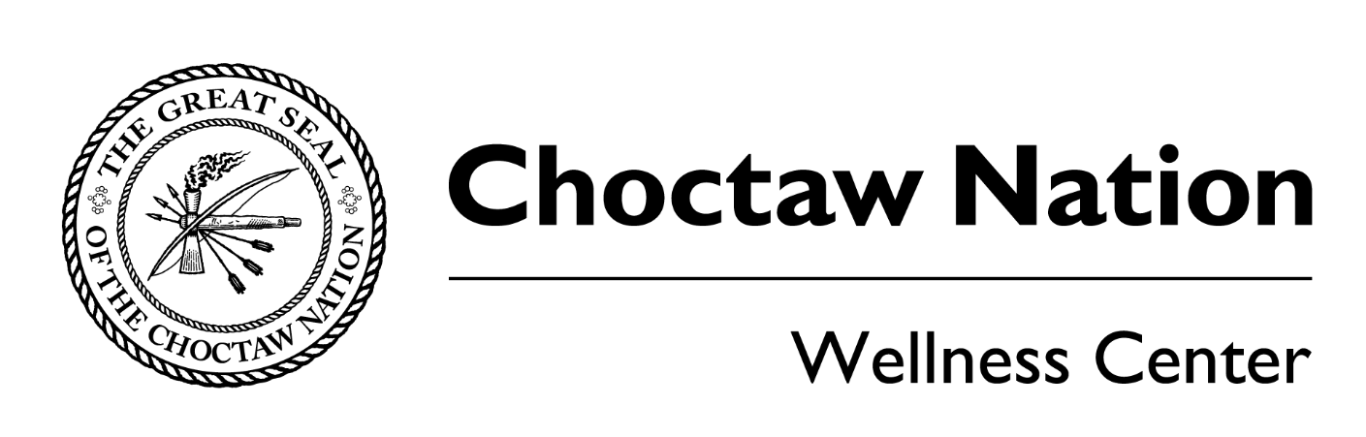
Please read the following waiver and release information
I am aware that there are potential risks involved in the participation of the Choctaw Classic. I acknowledge that participation in physical activity may cause health risk or injury and that the Choctaw Nation is not liable for accidents during this competition. I further give my consent for the Choctaw Nation to provide medical attention to myself in the event of an emergency situation.
By signing this agreement, I fully understand that I am responsible for any injury that may occur during the competition.
I, __________________________________________, hereby give my permission to the Choctaw Nation Health Services Authority the right to use, publish, and broadcast images of myself in any media (e.g., photographs, digital images, posters, videos, audios, World Wide Web, pamphlets or other publications). I am providing these services gratuitously and will not make any claims against the Choctaw Nation Health Services Authority for compensation on these services.

Participant name: _______________________________
Participant’s address: ________________________________
Emergency contact and contact number: _________________________________
Relation of emergency contact: ___________________________
Participant Signature: __________________________________

