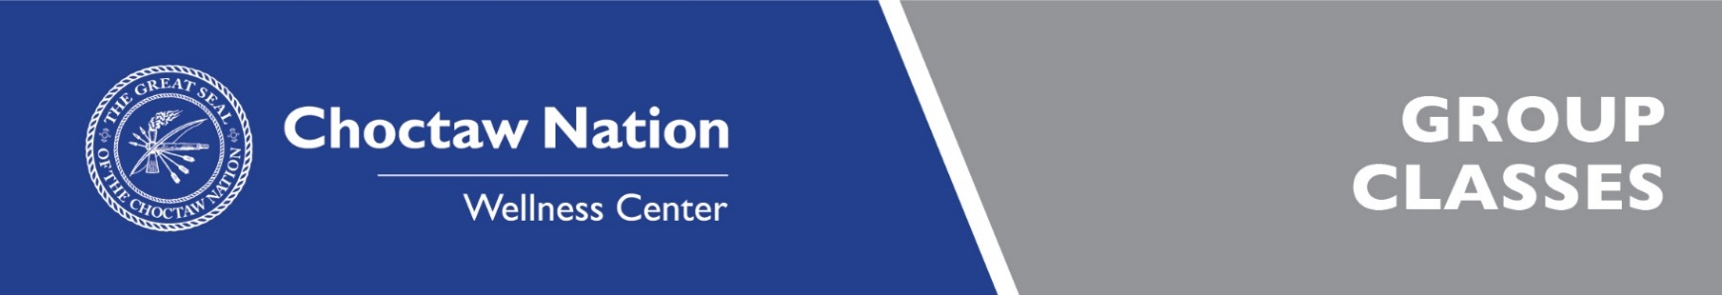

Time | Monday | Tuesday | Wednesday | Thursday | Friday
6:15-7:00 AM | KICKBOXING  (Ty Jackson) | CORE N MORE  (Sandra Jackson) | KICKBOXING  (Ty Jackson) | CORE N MORE  (Sandra Jackson) | MMA  CONDITIONING  (Ty Jackson)
9:45-10:30 AM |  | SILVER SNEAKERS  (Sandra Jackson) |  | SILVER SNEAKERS  (Sandra Jackson)
10:00-11:00 AM | JAZZERCISE LO  (Lisa Cannon) |  | JAZZERCISE LO  (Lisa Cannon) |  | JAZZERCISE LO  (Lisa Cannon)
10:30-11:30 AM |  | SENIOR  VOLLEYBALL  (Dan Trujillo) |  | SENIOR  VOLLEYBALL  (Dan Trujillo)
10:45-11:30 AM |  | ON THE BALL  (Tashona Burcham) |  | YOGA BASICS
12:05-12:45 PM | CORE N MORE  (Sandra Jackson) | RIDE N ROW  (Tobi Miller) | CORE N MORE  (Sandra Jackson) | RIDE N ROW  (Tobi Miller) | AMRAP  (Jordan Benson)
5:10-6:00 PM | BODY CAMP  (Tammy Ezell) | STATION TO STATION  (Sandra Jackson) | XTREME HIP HOP WITH KATHRYN | CARDIO & STRENGTH  (Tammy Ezell)
5:10-6:00 PM  5:15-6:00 PM | YOGA  (Melissa Landers) | XTREME HIP HOP WITH KATHRYN | YOGA  (Melissa Landers)
 | RIDE N ROW  (Krista Henson) |  | RIDE N ROW  (Krista Henson) | RIDE N ROW  (Krista Henson)
6:10-7:10 PM | BOXING  (Dustin Bowles) |  |  | BOXING  (Dustin Bowles)
6:10-7:10 PM  7:15-9:00 PM |  | TURN UP  {DANCE FITNESS}  (Kathryn Jernigan) |  | TURN UP  {DANCE FITNESS}  (Kathryn Jernigan)
 | TAEKWONDO  (Amy Hervey) |  |  | TAEKWONDO  (Amy Hervey)

COLOR KEY | STUDIO 1 | STUDIO 2 | STUDIO 3 & 4 | CYCLE STUDIO | FUNCTIONAL  FLOOR | BASKETBALL COURT

AMRAP – A high intensity, explosive training session that will engage the core by incorporating strength, power, and cardiovascular training. Complete AMRAP (As Many Rounds As Possible.) Burn calories, gain muscles, and have fun!!

BODY CAMP - Stations, interval training, and/or weight training. Whatever the instructor has planned will challenge your cardio and strength. Appropriate for all fitness levels!

BOXING –a beginner/intermediate boxing class that helps burn calories by developing speed, endurance, and hand eye coordination, all while learning the sport of Boxing. Learn punching technique and combinations then end class with a high intensity boxing workout!

CORE ‘N’ MORE - This short explosive workout provides full body strength training with a strong focus on the core. Appropriate for all fitness levels.

JAZZERCISE LO - An original dance fitness class that offers a fusion of dance moves all performed to the latest music! Improve your cardio, endurance, strength, and flexibility while having fun! Appropriate for all fitness levels!

KICK BOXING BASICS/MMA CONDITIONING - Develop your timing, balance, co-ordination, power, speed, agility, and flexibility. Start with jump rope and move into some punching and kicking combos with the use of gloves and pads. Finish up with some good core conditioning. Be ready to have some fun!

ON THE BALL – Strengthen your body and improve balance on a stability ball or BOSU ball! This is a low impact, total body workout emphasizing the core muscles! Appropriate for all fitness levels!

RIDE N ROW - A high energy, low impact workout which incorporates indoor cycling (spinning) and rowing to wherever the high energy music may take you! Go at your own pace!

SILVER SNEAKERS - Experience a variety of exercises designed to improve muscular strength, range of motion, and the activities of daily living. You’ll use hand held weights, elastic tubing, and a soft ball for each workout. A chair is always available if needed.

TAEKWONDO - Here you will learn training and technique for unarmed self-defense. It involves the skilled application of punches, kicks, blocks, and dodges. No gear necessary, must be age 10 or older.

XTREME HIP HOP WITH KATHRYN – A revamp of traditional step aerobics with routines set to old and new school hip hop. It makes you want to get up and move while getting a great calorie burn!

YOGA - Experience a variety of poses that increase your strength, balance, and flexibility. Great for relieving stress after a long day! Appropriate for all fitness levels!

YOGA BASICS – This slow-paced Yoga class is perfect for a beginner to learn the correct alignment and progressions of each pose. Come improve your balance, strength, and flexibility!

TURN UP – A dance based fitness class that involves dance and aerobic elements. This class incorporates salsa, samba, hip-hop, mambo and other dance styles all set to a Latin rhythm. The class is fun, so come join the party!

NEW CLASS! STATION TO STATION – Move from station to station for a full body workout using various equipment. Appropriate for all fitness levels!

NEW CLASS! CARDIO & STRENGTH - Give it all you got for an intense burst of cardio, followed by a strength period to give you a full body workout. Appropriate for all levels and includes various equipment.

