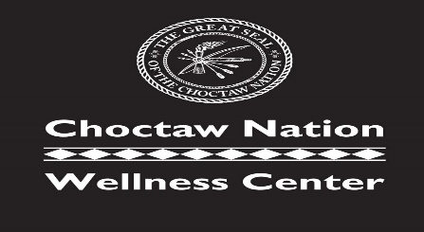
POTEAU GROUP
CLASSES

TIME | MONDAY | TUESDAY | Wednesday | Thursday | Friday | Saturday
5:00-6:00 AM | MORNING CRUNCH | MORNING CRUNCH | MORNING CRUNCH | MORNING CRUNCH | MORNING CRUNCH
6:00-7:00 AM | MORNING CRUNCH | MORNING CRUNCH | MORNING CRUNCH | MORNING CRUNCH | MORNING CRUNCH
8:00-9:00 AM | MORNING CRUNCH | MORNING CRUNCH | MORNING CRUNCH | MORNING CRUNCH | MORNING CRUNCH | SPIN
8:30-9:30 AM |  | LEVEL 2 YOGA |  | LEVEL 2 YOGA | LEVEL 2 YOGA
9:30-10:30 AM |  | ZUMBA |  | ZUMBA
9:30 –  10:15 AM |  |  | CROSSFIT  SENIORS |  | CROSSFIT  SENIORS
10:15- 11:00 AM |  |  | SENIOR YOGA
10:45-11:30 AM |  | TAI–CHI |  | TAI-CHI
12:00-1:00 PM | CROSSFIT | CROSSFIT | CROSSFIT | CROSSFIT | CROSSFIT
LEVEL 1
YOGA
1:00-3:00 PM |  |  | SENIOR VOLLYBALL
4:30-5:15 PM | KIDFIT | KIDFIT | KIDFIT | KIDFIT | KIDFIT
 |  | BARRE |  | BARRE
5:00 –  6:00 pm | LEVEL 1 YOGA | LEVEL 1 YOGA |  | LEVEL 1 YOGA
5:30-6:30PM | CROSSFIT | CROSSFIT | CROSSFIT | CROSSFIT | CROSSFIT
6:00-7:00PM | SPIN |  |  | SPIN
6:30-7:30PM |  |  | OLYMPIC WEIGHTLIFTING
8:00-9:00PM | CROSSFIT | CROSSFIT | CROSSFIT | CROSSFIT | CROSSFIT

COLOR KEY | STUDIO 1 | STUDIO 2 | BASKETBALL COURT | CROSSFIT ROOM

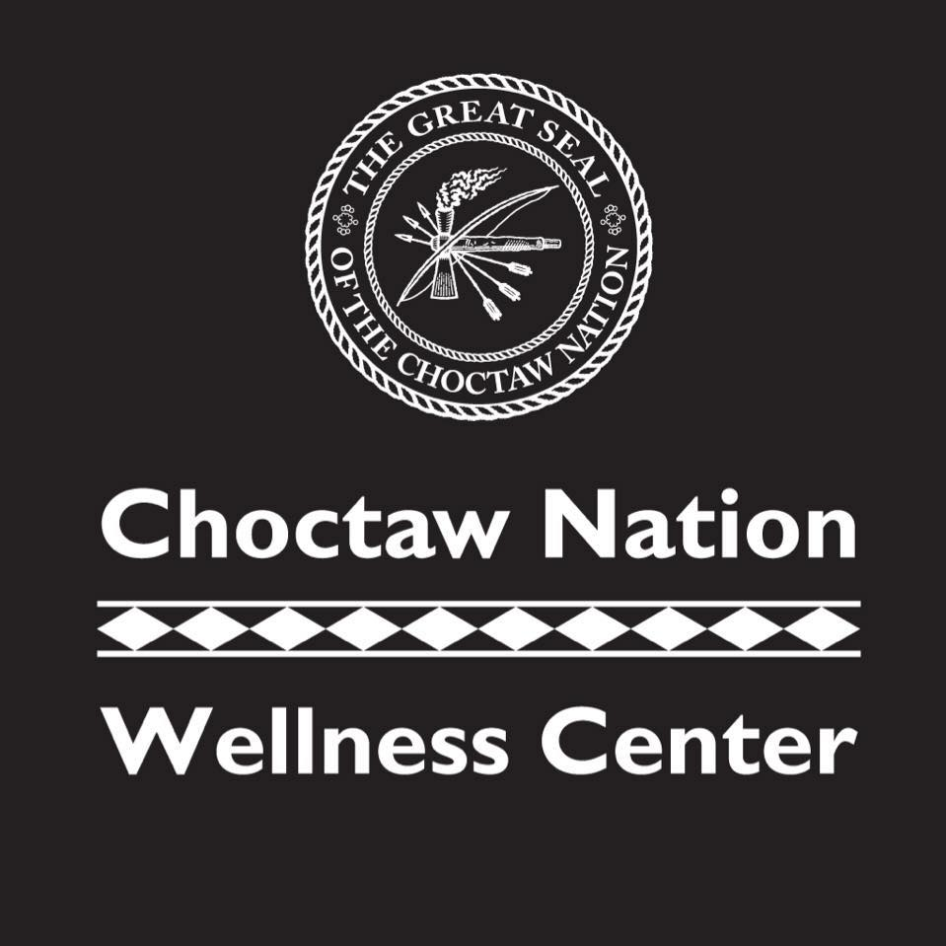
CLASS DESCRIPTIONS
MORNING CRUNCH – High intensity training is sure to get you fit fast! Give it all you got for an intense burst of exercise, followed by a brief recovery period which will get you ready to go hard again!
CROSSFIT - CrossFit is a lifestyle characterized by safe, effective exercise and sound nutrition. CrossFit can be used to accomplish any goal, from improved health to weight loss to better performance. The program works for everyone—people who are just starting out and people who have trained for years.
OLYMPIC WEIGHTLIFTING - Olympic weightlifting consists of two types of lifts: the snatch, and the clean and jerk. Both are overhead lifts and involve a full body range of motion. The goal is to lift maximum weight at a rapid speed using a barbell.
YOGA – LEVEL 1 – Experience a variety of poses that increase your strength, balance, and flexibility. Great for relieving stress after a long day! Appropriate for all fitness levels!
LEVEL 2 – Is heated and more vigorous and complex than level 1. With plenty of sun salutations and breathwork by introducing more advanced postures and transitions.
SENIOR CROSSFIT – A fun and functional fitness program that targets: strength, endurance, balance, flexibility, and coordination.
ZUMBA – A dance-based fitness program that involves dance and aerobic elements. This class incorporates salsa, samba, hip-hop, mamba and other styles all set to a rhythm. This class is fun, so come and enjoy the party!
TAI-CHI – A self-paced system of gentle physical exercise and stretching. Each posture flows into the next without pause, ensuring that your body is in constant motion.
SPIN – A high energy, low impact workout which incorporates indoor cycling (spinning) with fun music! Appropriate for all fitness levels.
BARRE – Inspired by Ballet, Pilates, and Yoga. Barre will tone your entire body!
KIDFIT – This program develops and improves general physical fitness by building on the foundation of FUN!

POTEAU CLASS INSTRUCTORS
MONDAY – FRIDAY | INSTRUCTOR
MORNING CRUNCH | KRIS PICKLE
CROSSFIT | TORI JOHNSON  ADAM HACKMAN  BRAD DORSEY
YOGA | TORI JOHNSON  STEVIE BRUESCH
ZUMBA | KRIS PICKLE
SPIN | DANA PARKER
KIDFIT | MICHELE BAKER  JENNIFER BRANSCUM
OLYMPIC WEIGHTLIFTING | EVAN FREEMAN
BARRE | CINDY WOOD
CROSSFIT SENIORS | TORI JOHNSON
TAI-CHI | KRIS PICKLE

